Written by Marie and Gunhild
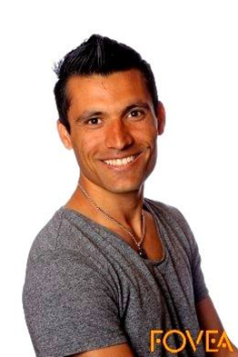
Sifat is a 21 years old boy, who moved from Afghanistan to Norway. The reasons why he moved was war, poor economy and he wanted the opportunity to go to school. Before he came to Norway, he lived Turkey, Iran, Greece, Italy and France. He did not know anything about Norway before he moved.
He jumped into a truck in Greece, and thankfully, it stopped in Sweden. Then he took the train to Norway. Before the 14-year old boy moved, he had to think about how it was to live without his family and friends. It has now been eight years since he last talked to his father.
There are many differences between Afghanistan and Norway, for example the rules and the political system. He says that Afghanistan is a democratic state, but it is not working quite well. It`s characterized by discrimination and racism. In Norway, you can tell your opinion freely without finding yourselves in danger. On the Afghan National Day, the military forces walks in a parade to show their power. While in Norway is it the other way around, it`s the children who walks in the parade, to show that we stand together, celebrating peace and that it`s the children who are our future.
He says that the health care in Norway are better, and that it`s easier to get to the hospital with an ambulance or a helicopter. Before, Sifat lived in a village with 26 000 inhabitants, around 70 km from the city. It is long distances, so it is not easy to get to the hospital.
The cultural differences in Norway and Afghanistan are quite big. The culture in Afghanistan very influenced by the old traditions, while Norway has a culture that keeps on changing. Norway is a democratic and multicultural country, which tolerate people with different backgrounds and cultures. Sifat feels that the culture in Afghanistan are controlled by conservative old people, he still feels that it`s important to keep a bit of the old culture, but also important to give room for new impulses.
The process of getting into the Norwegian society was a bit hard, but he found it easier to connect with people after going to Norwegian classes, learning the laws and the politic system. The Norwegians are different from the Afghans, and they behave very different in many ways. People from Norway nearly say hello and nod to each other, while in Afghanistan they talk and give hugs to people they do not know, and are generally more open even to stranger. That made the situation of getting new friends a bit hard.
His perspective and interests have changed a lot because of the migration, but also by the fact that he has grown up. He was only 14 years old when he left his home, and are now an adult. Back in Afghanistan he was a part of a cricket team for almost 11 years, still he had never played football. He could do almost what he wanted, but he could never feel completely safe because of the war that was around him. Sifat says that he behaves like before, but he has changed the way he think. One of his new hobbies in Norway are downhill skiing, and he has also tried cross-country skiing, but have not figured it out quite yet.
Some of the things he brought with him from home was some of the Afghan-customs, like the celebration of the Afghan National day and Afghan New Year. He have also kept his Afghan food. He likes the Norwegian food as well, but he does not know how to make it, therefore do he mostly make Afghan food. He has grown fond of the Norwegian society and culture, but he will never loose or forget his Afghan background.

Written by Therese and Inga
Interview with Arnar
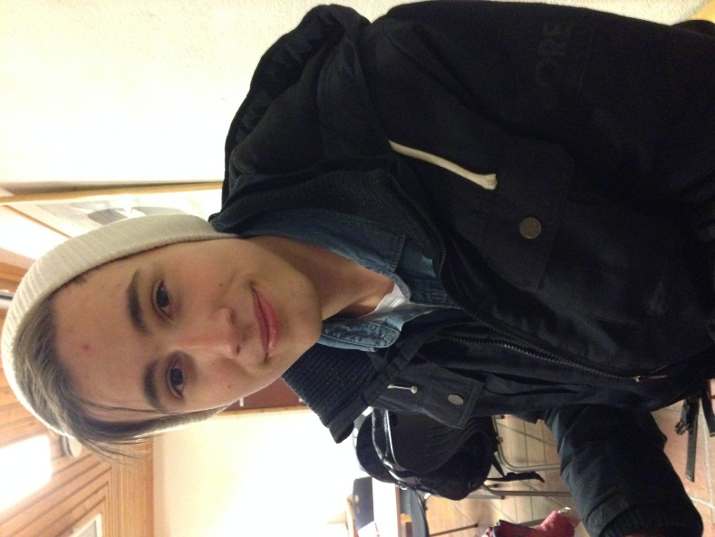
We have interviewed Arnar, an eighteen years old boy originally from Iceland. Arnar was born on Iceland, but moved to Norway for the first time when he was five. He moved to Norway together with his family, they wanted to try something new, and his mother was going to study here. The fact that they ended up in Norway was a little bit of a coincidence, but the choice were between the Scandinavian countries, Sweden, Denmark and Norway. They didn’t know anyone from Norway, and little did they know about the country. The only thing Arnar had been told was that all Norwegians lived in cabins, something he quite fast figured out wasn’t true. Because Arnar first moved here when he was five years old, learning the language never was a big challenge.
When he was thirteen years old, Arnar and his family moved back to Iceland. They missed the rest of their family and friends. However, they only lived at Iceland for three years before they moved to Norway again. This time because Arnar was attending senior high school, in his opinion the school system is a lot better here in Norway than on Iceland.
Arnar has now lived in Norway for ten years, and he has no longer that much contact with his family on Iceland. But he has some contact with his old friends and his uncle. Arnar does not want to move back to Iceland, he feels a lot more at home in Norway and he says he feels like a Norwegian. Arnar thinks moving to new places is a good thing, you get to experience more and you become better at adapting to new environments and places. However, he also says it got its disadvantages, like for example that you are not able to make those strong friendships as easily.
Iceland and Norway are pretty similar in some areas, but there’s also many differences. Iceland is not as rich as Norway, but has anyway almost the same living standards. The health care is better in Norway though, on Iceland you have to have health insurance to get treatment if you become sick. It’s also fewer ways to get around on Iceland if you don’t have a car. They don’t have trains, subways or trams either, most people therefore use the bus. However, they probably don’t need anything else than the bus, because most of the inhabitants live in the capital. Actually, 60 % of the population live in or nearby Reykjavik, which has approximately 120 thousand inhabitants.
They don’t have that many refugees coming to Iceland either, which is one of the reasons of why Christianity is more prevalent. But when it comes to how Christian each person are, there is almost no difference between Norwegians and Icelanders. And they still have a state church. Another difference is that “senior High School” is much more like the universities we have in Norway. They have much more responsibility for their own learning there, and have to buy all the equipment for school themselves. The grade school and the junior high school are not divided into two parts as it is in Norway, it’s just like one big school. From the 1th year they get grades. So the school on Iceland is more strict, and that the small kids don’t get it as easy as they do here. In Norway we have a much more “calmer” transition from kindergarten to school (1th, 2nd, 3rd).
The nature on Iceland is much alike Norway, but there are almost no trees. And they have more volcanoes and mountains. Because they don’t have trees, the houses are built up by bricks, you rarely see a house made of tree.
Arnar thinks that some of the biggest differences are the people. According to him, Norwegians are happier and accommodating. In Iceland they were more “assholes”, not that easy to get to know and not that nice. In Numedal, he thinks people are particularly pleasant. We have a much smaller society here, and everyone knows everyone. And because of that we are more nice to each other, not as supercilious as most people from big cities. He likes to have calm surroundings. So therefore, he likes the countryside better than the city, because there are fewer people here and lesser stress.

Written by Hanna and Kristina

Written by Hanna and Kristina

Ibrahim Arpaci Travelogues Interviews
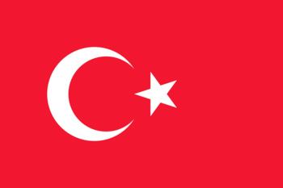
Ibrahim has a wife here in Norway that he met for a few years ago. This made him move from Turkey, what is his homeland, to Norway. This woman already had one child when he met her, but after some years, they did get some children together too. He found it easier for him to move to Norway instead of taking the child and his woman to Turkey. “When I lived in Turkey, I lived in a big city with a lot of people, so when I moved to Norway, this little place Uvdal, I had to be used to so few people” did he say while giggling. Ibrahim did fit very well in this culture, since Norway and Turkey doesn’t have so different cultures. The most different thing from Turkey to Norway, is that the teenagers in Turkey did have more respect for the elders then the teenagers in Norway does. He thinks it was a challenge to learn the Norwegian language. When Ibrahim moved to Norway, he also had to get used to so much snow, long winters and colder temperatures. Norway is known with a lot of skiing, but Ibrahim didn’t need to train much on skiing, because he was already skiing while he lived in Turkey. Norway does also have a fantastic nature and nice mountains, and this made Ibrahim to get sportier. He didn’t walk to much in Turkey, because of the city he lived in was so compact, and there were a lot of people everywhere, but when he moved to Norway, he was glad to take a trip around in the nature. “I do still make Turkish food…” he loves to surprise his wife with Turkish food, but there aren’t everything she can eat, because of her celiac Disease, but he do still makes the food that she can eat. Thought for our easy-made-Norwegian-food, does he still like the taste of Norwegian food.
The education system is also different from Turkey to Norway. In Norway do we have to go to school in 10 years, but in turkey, they do just have to go to school in 8 years. The start age to go to school in Norway is 6 years, and in turkey, they have to be 7 years.
Ibrahim tells that his friends and families were positive when he decided to move to Norway. He still make contact with his friends and family from turkey. He also says that he does not miss his old neighborhood in Turkey so much, and that the communication between the old neighbors slip away. Making new friends was not a problem for Ibrahim. He works as a teacher at Numedal High school. He teaches mathematics, and thinks the job is a bit challenging, but that comes with experiences and that is exciting, he says. When it comes to the unemployment here in the local government, he means it is low and the job opportunities are not varied. Even though you can find a job that fits you.

He has a very normal attitude when it comes to how affected he is by the migration. He did not have so many expectations when he moved to Norway. At first, he missed his parents and friends, but then he got two children whom helped him get okay with it, and just the thought of having a family, also helped him. Before moving to Norway, he lived in Malta for about 2 months, and got some experiences there. Temporary he has no plans at moving back to Turkey, because of his happy life in Norway with his family. Here in our local government, there is not much opportunity for shopping, and only one casualty clinic. Where he came from it was not like that. “There were much more shops, clinics, cafes etc.,” he says. In the area he grew up in it was not that much trees, forests or valleys as it is here in Norway. The climate was a bit gentler. We did also had snow, high mountains and big plateaus. He wishes that in Norway, the winter and the dark days could be shorter.

Interview with Ibrahim Arpaci part 2
Ibrahim tells that his friends and families were positive when he decided to move to Norway. He still make contact with his friends and family from turkey. He also says that he does not miss his old neighborhood in Turkey so much, and that the communication between the old neighbors slip away. Making new friends was not a problem for Ibrahim. He works as a teacher at Numedal High school. He teaches mathematics, and thinks the job is a bit challenging, but that comes with experiences and that is exciting, he says. When it comes to the unemployment here in the local government, he means it is low and the job opportunities are not varied. Even though you can find a job that fits you.

He has a very normal attitude when it comes to how affected he is by the migration. He did not have so many expectations when he moved to Norway. At first, he missed his parents and friends, but then he got two children whom helped him get okay with it, and just the thought of having a family, also helped him. Before moving to Norway, he lived in Malta for about 2 months, and got some experiences there. Temporary he has no plans at moving back to Turkey, because of his happy life in Norway with his family. Here in our local government, there is not much opportunity for shopping, and only one casualty clinic. Where he came from it was not like that. “There were much more shops, clinics, cafes etc.,” he says. In the area he grew up in it was not that much trees, forests or valleys as it is here in Norway. The climate was a bit gentler. We did also had snow, high mountains and big plateaus. He wishes that in Norway, the winter and the dark days could be shorter.

Written by Juliea and Torbjørn
MIGRATION FROM CHILE TO NORWAY
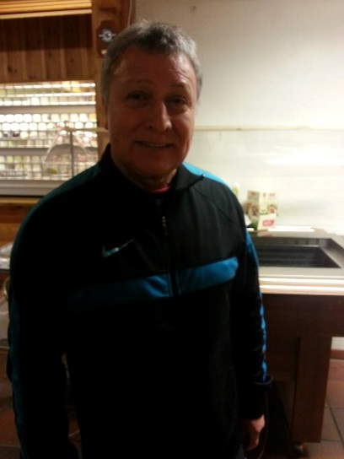
We interviewed our gym teacher who is originally from Chile. He was born November 24, 1954. He has a wife and two kids. His son is 32 years old and his daughter is 35. He migrated here in Norway because of political reasons. Chile was under military dictatorship so he had to leave the country for a better life. There was no time for many preparations because it will only cause conflict between him and the government so he had to leave as soon as he possibly could. He had to leave his entire family and migrate alone. He was to leave the country alone and not tell his family but he did not want them to worry so he informed his wife and kids. He could not tell his mother because she lived 80 miles away and because she was old too. He could not risk having his mother worry about him leaving the country. It was very dangerous at that time and would have caused him his life. He informed his mother a year later after he found out that he could permanently settle here in Norway. His family followed him through family reunification.
According to Jose, there is quite a difference between the system here and Chile. There, you would have to buy insurance. There are better offers when it comes to health care here in Norway. He does not find it difficult to follow the laws here in the country since Chile was a part of the Spanish colony, which is European. From living in the city to transferring in the countryside was a big change for him, but he said that there are many positive sides in living at a little place. It is much easier to get to know and connect people who also lives in the same area. He also said that people here act different from the people from Chile. Norway is not used to receiving people. The land is more reserved. However, if you start getting contact with people then it is smooth sailing from there. He said that the migration was not very easy for their kids, but it was not so much stress including the fact that his kids were so young that time that they could easily fit in than adults do. There is huge difference when it comes to languages because Norwegian and Spanish are two different languages. It was not easy for him to learn a very different language.
Norwegian and Chile culture are very much alike so not much of a difference. However, there are also different holidays like national day since they are both different countries, but since it is a lot of the same culture, it is easier to blend in with the community. Jose and his family still celebrate traditionally dates from Chile and worldwide traditions like Easter and Christmas. Jose has many hobbies. He likes sculpturing and different art and he have been studying art in Norway. Technically from being a math teacher into art. He have also been studying language and gymnastic. Jose have always been doing a lot of sport in his entire life, no wonder why he is a gymnastic teacher today. There is a big difference between the school systems in Chile and Norway. In Chile, it is mostly private school, in Norway, you have right on 10-year school, and the government covers it all. In Chile, the education is more for the people who have money since you have to pay for the school yourself. Public transport is no problem for Jose since both he and his wife drives a car. There is a quite big difference in the environment with the weather; of course, the summer time weather is quite close but in the winter, its very cold and very much snow in Norway while it can still be hot in Chile. Jose said that the community in the place has common principles.
Jose likes it here very much and have lived here in Norway for over 20 years. Although he likes it very much, he is still as dedicated and loyal to his homeland. He said that no matter how long he lived here in Norway; even if it is longer that the years he lived in Chile, his hear would always remain loyal there. Born as a Chilean, always will be one. No matter where he is in the world.

Written by Sifatullha (and Mehmet ?)
- The person I interviewed was Kristine Haugen. She is a girl from Sweden, but she moved to Norway when she was 17 years old. She moved to Norway because of education and work. She think it’s easy to get work here in Norway then Sweden. She didn’t moved because of political situation, but because of school and work.
- The reason for choosing this location was that she have been several time to Norway and she have some family and friends here. So it was easy for her to come here said ‘’She. She spend a lot of time to find some good place to live and she prepare that she going to meet new people and culture. She can speak Norwegian now. Yes, she gave up on her old friends and many others thing. It wasn’t easy for me to move, but I just like me here in Norway.
- The rules and laws are almost the same, but maybe a little different. The healthcare’s in both places are almost the same, but I think healthcare here in Norway is better than my country. Of course it’s different to live in countryside than a big city. In countryside you know a lot of people from everywhere, but in big city it’s difficult. Countryside is more peaceful than a big city!
- Yes people act differently here in Norway than Sweden. Norwegian people are more warm and want to get contact with new people. But Swedish people are a little bit could people. It’s take a lot of time to get know with Swedish people!
- The cultural life is pretty much the same. But of course it’s a little different in some way. I have respect for both cultures, because Norwegian and Swedish culture are almost the same.
- She said that she like to stand on ski much more now than before. She said it’s really funny to stand on ski and every weekend I’m at alpine center.
- The change she made in her daily life is that she is with her new friends much and she work much here. She is happier with her life than before! I think I will never move back to Sweden. I like me here.
- It was difficult to make new friends yes. It’s took a lot of time to get know people here, but I tried very hard to get know with people and make new friends. Today I have a lot of Norwegian friends. They are so nice to me all the time.
She still has contact with her old friends and family. She talks with them a lot and sometime she misses them. My parent wasn’t so happy for that I moved. But I talk a lot with them. But today they are positive to me and they visit me here sometime. When they are here in wintertime, we going outside a lot and stand on ski!
Norway is colder than Sweden. Here we don’t have so much sun, but in Sweden we have longer summer than Norway.
The thing I’m not happy with in my new location is traffic. It’s expensive to travel with bus or taxi. You have to pay a lot of money. Norway is a very expensive country, but people have work and they get much money.

Written by Esrar (and Benjamin?)
Migration Mehdi Amani
Mehdi migrated from Afghanistan to Norway, because of war. The reason was his brother, because he has his big brother here in Norway. The situation was the same for both of them. His brother came to Norway in 2003 almost 10 years ago he came a lone to Norway. He is saying that actually coming to Norway or coming to any of the European countries is not so easy it is too difficult, he moved from Afghanistan in 2003 to Quetta Pakistan on that time he was just 11 years old. He started to work in a bakery from there he collected enough money to came to Norway. He migrated illegal over the borders. According to Mehdi here in Norway and in Afghanistan it’s two different laws, rule and regular. I think in Norway healthcare is much better. First of all, he grew up in a big city he saying that for the first time when he came to the countryside it was boring but now it is going better. He is pointed that it is difficult to come in the new society where they have different language, different culture. Actually, it the beginning everything is difficult but later it is going well. Here in Norway and in my hometown there are a lot of differences, like culture and tradition and he is celebrating some of his hometown tradition here in Norway with other Afghans, he get free from school for that. He has a lot of hobbies. He like football, volleyball and off course dance, his favorite team is Real Madrid. He has changed himself a lot. For example: clothing style, hairstyle etc.
In his point of view there is a lot differences in education system. Like here, we are using computer in the class during the lesson and there is different method of teaching as well. In fact, he didn’t have a lot of school background from hometown. He has been till 6th class in homeland. All of his friends are very happy that moved here and he has contact with some of his friends. He is enjoying with his friends and happy with school. He is not working, just going to school. He moved to Norway to have a better life in the future and to be educated. He mentioned that he didn’t want to spend his whole life in the bakery. He will be here for the rest of his life not here in the countryside but in a big city. He likes everything here but not the snow. The landscape is quite same in the both countries here is a lot of mountains and there is also a lot of mountains, the difference just that here is trees on the mountains and there is not trees.

