Migration summary
We interviewed two people from different age-groups about the circumstances of their migration. One person is a married woman – housewife - in her thirties, the other person is a student at the age of twenty. Let’s see the differences and the similarities of their answers.
The reasons of their migration were different. One moved from Barcs to Kaposvár because of higher education, as Barcs has no such facilities. Furthermore she settled because she found her mate. The other person’s reason was her family. First she moved from Csurgó to Drávatamási – a small village – because her husband lived there, then after their son was born, the whole family moved to Barcs, thus the child doesn’t have to commute to kindergarten. Though their workplace is still in Drávatamási.
To give some details about the towns, we have to mention that neither of them moved that far away from their hometown. So we can’t talk about cultural, climate, social structure or language differences. Csurgó is almost the same as Barcs. Our county – Somogy - is centralized in Kaposvár, the county seat, that’s why it has a developed infrastructure, for example it has a hospital, a university, shopping centres etc. It is a bigger town, there are more facilities to study, to do sports, to find a workplace or to entertain.
The preparations were about the same. They both bought a flat as a place to stay is needed to start a new life in a new place. The older interviewee had to give up on living with her parents and her job, but is satisfied with the current one. Then other was too young to have something to give up.
The hardest thing for both of them was to integrate in society as they had no relatives, friends or acquaintances. Of course they still keep in touch with their family. Both families were satisfied with the moving of their daughters, because in their case moving meant the starting of a brand new life, which they have craved for so long.
Their lifestyles have changed a lot, one of them is taking care of her baby parallelly with her job, so she doesn’t have any free time. The other is still not married and has no children, that’s why she has enough spare time to do more sports and to entertain. It is evident, as she is just 20 years old.
We can say that they are contented with the change as they met their expectation.
All in all if we are considered it was good to see how the different generations are able to start a new life and it has advantages for us, as it will help us to decide about our own migration in the future.

Migration within Hungary

We interviewed two spouses about their migration. We asked various questions in connection with moving and changing lifestyles. Their answers were not surprising due to the present circumstances.
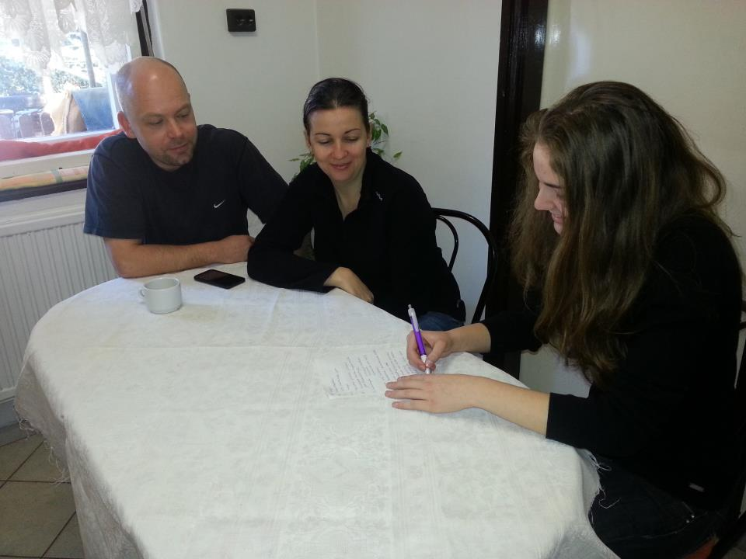
They first stated that they moved because of better job opportunity but added that friends had also recommended the place. To the question if they had made any preparations before moving they answered that they packed their boxes, hired a truck, threw a party and bid farewell. They had to abandon their former jobs and the children’s nursery and there was no choice other than ethnic education.
They found the situation of healthcare similar to what they had experienced before, but integrating within a new community proved difficult. The children love their new homes but miss the closeness of their family and friends.
Although people speak in a different dialect because of their swabian origin it caused no problem. The cultural life is flourishing and there are always some events in which inhabitants can participate.
They took on new hobbies like mountain biking and other sport activities. It was not easy to add these new programs to their daily routine because they had to solve the problem of commuting.
They only see their families on rare occasions but they still do their best to keep in touch even with their old neighbours.
They claimed the moving had affected them in a quite positive way because of the better circumstances and challenging job opportunities. Eventually, they could also make new friends.
However, help would be needed for raising the children but it is not available due to the distance. They had moved several times before but the question of babysitting was not so complicated as they only moved within the region. They had already entertained the idea of moving abroad but they still cradle hopes.
The climate differs significantly. Because of mountains the weather is a lot colder and spring blossom comes later.
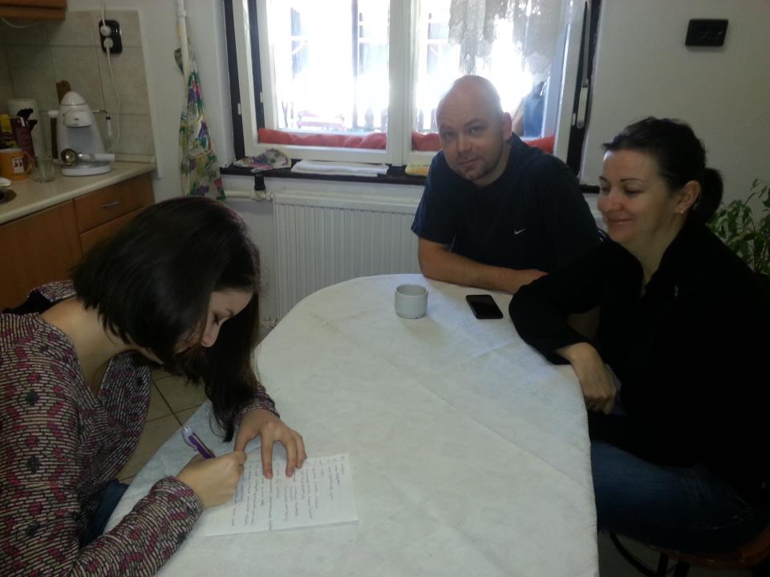
More and more people flock into big cities because the financial crisis is less impacting. Our interviewees are not the only ones who decided to change their lives. We are jealous of them.

