Belgian interviews

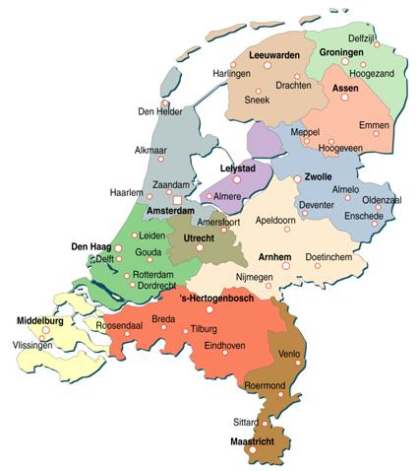
Group 1: Wouter and Stien

Report Immigration Interview

We interviewed Ljia Xu, a woman from the Netherlands who moved from China to the Netherlands when she was young. She has lived in Rotterdam with her aunt for 10 years. Then she married her husband who's also from China, but he grew up in Amsterdam. They settled in Hague (Den Haag), a city between Amsterdam and Rotterdam. They had two kids there. After living together for 19 years in the Netherlands, they moved to Belgium to take over the frying (French fries shop) Finesse in Tielen. They have been living here for longer than a year and everything goes well.

To emigrate out of the Netherlands, where she worked in the hotel and catering industry and where he worked in a bio-shop, was a very good plan for them. Their friends live in all different cities in Belgium and the Netherlands. Some of them live in the towns in which they grew up, Amsterdam and Rotterdam, some live in Hague, where they lived for 9 years, but also in Antwerp and Eindhoven they have friends. That's why it doesn't matter where they exactly live. Tielen is even closer to Antwerp and Eindhoven than Hague. Mostly, they keep in touch by telephone, but they also chat often. Ljia Xu also calls her parents, brother and sister frequently. Another reason for their migration are the laws: in the Netherlands they're more strict laws than in Belgium. Here you don't have to obtain a diploma for owning a store, in the Netherlands you do. She could use the diploma which she got in the Netherlands in Belgium. In the Netherlands there are rules for starting a shop in a certain area, in Belgium we don’t have that law. That's why it’s better to take over a store in Belgium.
They thought migrating to Belgium would be easier than moving to any other country because we speak the same language, but that wasn't all true. The first 2 months they have had problems with understanding our Flemish accent, but that improved quickly.

The kids didn’t have problems with their movement. They have 2 boys: one in the first grade of the primary school and one in the last grade of the nursery school. In the beginning, they regretted that they had to leave their school friends, but once they lived here, they didn't even miss their school in Hague. Mama Ljia did notice some difference between Belgian and Dutch education. She thinks Belgian schools are more strict than Dutch ones. Here pupils have to do homework from the first grade of elementary school, in the Netherlands homework starts in the third grade. In the Netherlands, social contact with the teacher was better than here: the kids are picked up in the class, instead of on the playground, so the teacher can tell about how your kids behave in class. The focus is more on welfare of the kids, while here the focus is more on performance. She noticed that her oldest son advanced better than in the Netherlands by doing homework and reading short books every day. In the Netherlands they exercised reading only in class, not at home. Of course the difference between schools in Belgium and the Netherlands is much larger with China. There, classes with 60 pupils are no exception! You have to be very good to graduate. If you fail for one subject, you don't get any second chance. Only the very best ones reach the finishing line.

Ljia thinks that there is a big difference between Belgian and Dutch mentality. She told us that it's true that Dutchmen are more open than Belgians. When there is something wrong, they just tell it, while Belgians prefer to keep their feelings to themselves. The contact with their neighbours in Hague was better than the contact with their neighbours in Tielen. They also lend each other stuff. Here, it's nothing more than a greeting in the corridor.

They haven't made many friends here. They’re always very busy with the friary (French fries shop), and even on Sunday, their closing day, they have little time. Then they have to go shopping, clean the house and look after the children. However, they regularly try to visit their friends in Antwerp and in the Netherlands. A visit to China is unfortunately not often possible, because it's expensive for four people.

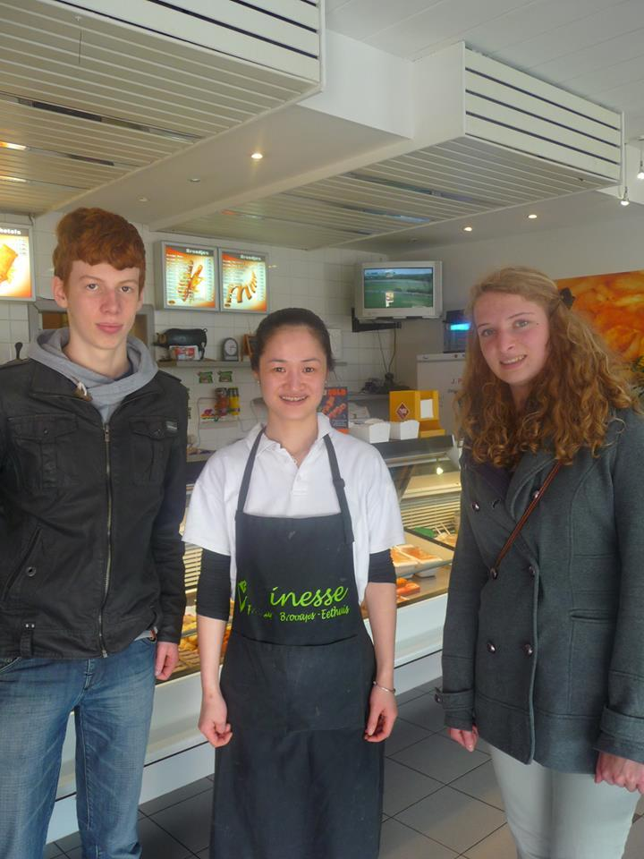
At this time, they still have Dutch nationality and a residence permit in Belgium, but there are no plans to leave Tielen. Everything goes well with the business, the children do well at school, they love the quietness in the peaceful village,...

Group 2: Jolien and Sarah

Travelogues
Paula emigrated from Scotland to Belgium because her husband had a job in Belgium. She didn’t move directly from Scotland to Belgium, first she lived in Italy for a while. She moved to Kasterlee in the first place because her husband had a job in Beerse, a city located 15 kilometers from Kasterlee. A friend helped them to find a house in Belgium. They ended up in Kasterlee and first hired a house they found. Because they have children, they wanted to stay and bought a house. They moved directly to Belgium, so they didn’t prepare much because they lived in Italy at that moment. They looked forward to the north of Europe because her husband lived in the Netherlands and he had a lot family there. At the moment she moved to Belgium, she thought she hadn’t to give up a lot, but afterwards she realized that she gave up a lot.
The rules and laws in Belgium are very different. Belgium has another culture than Scotland. For example, you don’t make a fire in your garden in Belgium. In Scotland is that is a very normal thing to do; everybody in Scotland takes the leafs from the trees to make a fire with. There are still other rules and laws which are different.
The level of the health care is a little bit different, because is everything almost for free in Scotland. You do have to pay for it, but not as much as in Belgium. You don’t have to think about how much money you have to save for medicines. In Belgium, it’s totally different. She likes the system in Scotland more than our system. She was a midwife herself and worked in the health care. So she can have a different opinion about it, because she is really close to this subject.
It is totally different to live in the country and then move to a city or the other way around. Here in Belgium you are never really in the middle of nowhere, except in the Ardennes (which is located in the Walloon part of our country). When you are in the country in Scotland, you are really in the middle of nowhere.
It was not difficult to adapt, because Belgium and Scotland are not very different of each other. When you look to someone from Morocco, it is totally different. They come from a totally different culture, while Scotland is also a Northern European country.
The people in Belgium behave themself very different. They are more detached when you meet them at first. The people were very much on their own in the beginning. She had to do a lot of effort to get a group of friends, but once she was in the group, everything was alright. It was not easy in the beginning because in Scotland they are friendlier and more open and here, that is less the case.
For her children, it was very hard to adapt, especially for the oldest one. He only spoke Italian and English when they came to Belgium. They had a choice to send him to a European school with English-speaking people or to an ordinary school in Kasterlee. They decided to send him to an ordinary school. It has been 13 years that she moved to Belgium. In those years she was the only one in Kasterlee, who wasn’t born here. Now it is totally different, there are much more foreigners in Belgium. Concerning that, the enterprise changed.
The cultural life is comparable. People here in Belgium love to go ride a bike and afterwards they look up a terrace to have refreshment. She likes that very much about Belgium. They don’t do that in Scotland, ‘een terrasje doen’ (to go and drink something on a terrace of a pub) like people say that in Belgium doesn’t exist in Scotland.
There are traditions from her own country she still holds on to. In Belgium we have ‘Sinterklaas’. That doesn’t exist in Scotland, there it is Santa Claus. He comes to bring presents in the night of 24 December. At school, her children discovered ‘Sinterklaas’ and she had to adapt to this tradition and participate, so her children wouldn’t be bullied at school by not getting presents from ‘Sinterklaas’. She had the same problem with Easter and the Easter bunny. She is sure that most of the parents that migrate to Belgium face the same problem.
Her family was very sad when she left, but she ‘s still in touch with them. Although she hasn’t got any contact anymore with her friends in Scotland, she does have a lot of friends in Belgium. It was hard to find new friends, but her children made new friends so she could socialize with their parents. It would’ve been harder without her children.
In Scotland she was a midwife. In Belgium, she couldn’t do the same job, because she didn’t have the right diplomas. If she wanted to do the same job, she had to go back to school, but she didn’t. Now she’s a volunteer. She teaches English in De Warande. She feels sorry she had to give up her work as a midwife. She didn’t expect a lot from Belgium, but she thought that everyone spoke French here. She had been in Belgium before and she expected it to be the same as in Scotland. There are a lot of benefits and disadvantages from leaving your own country. One of the biggest disadvantages is the difference in language. It isn’t easy to learn a new language, but you have to do it, to communicate well. In the beginning, it is a kind of handicap. Paula can speak Dutch now, but when she meets new people she’s always a little bit nervous. Another benefit, for my children, is that they don’t get to see their grandparents very often. Normally, grandparents take also care of your children, when you live that far from them it isn’t possible. The band with your family lacks. It’s a reason why you would want to move back at some moments. That’s also a hard decision, because she feels she is a half-Belgian now. Previously, she lived in a town in Scotland comparable to Antwerp. She took the bus to get to the center, where you had all the stores you needed. It’s different to live in a village like Kasterlee. Bigger stores are further away. Also the environment is different. In Scotland, there are a lot of hills while Belgium is more flat.
She knows a lot of people with higher qualifications. With their education, they can get a job in Scotland, the Netherlands, and Germany. But in Belgium it isn’t possible, because their education isn’t good enough. It would be nice if that changes so everyone can get a job with their qualifications.

She’s a real inhabitant of Kasterlee now and she likes the atmosphere here the same as in Scotland. She knows a lot of people here, which makes it comfortable to live here.

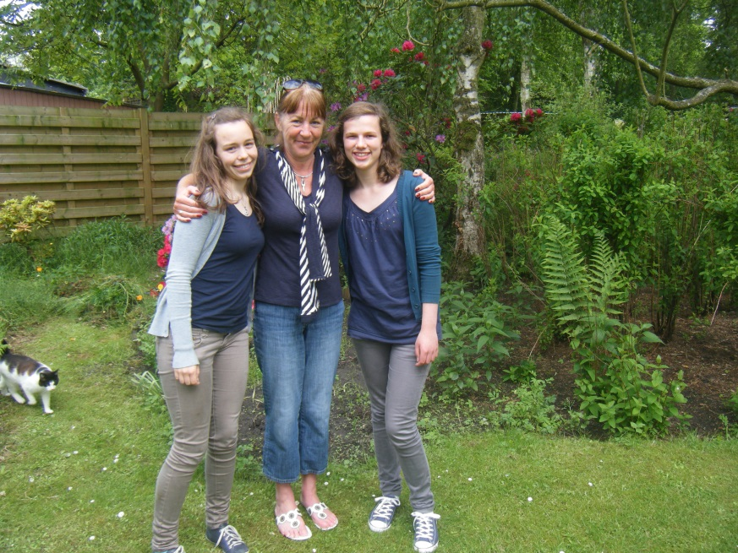

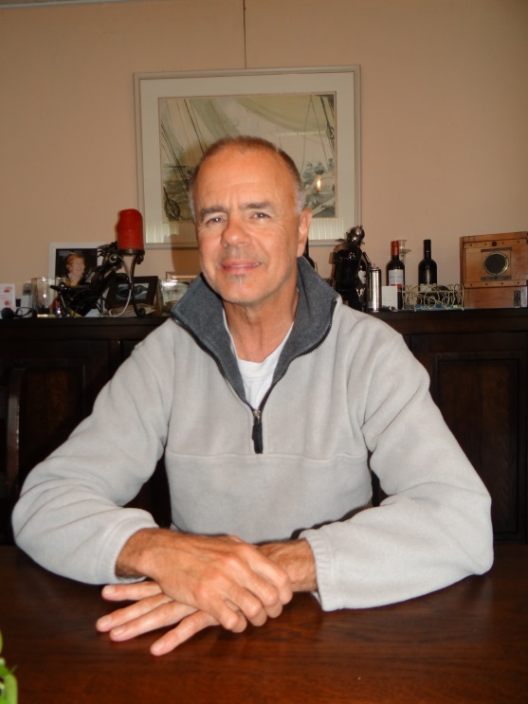
Group 3: Lotte and Ines

George comes from Canada. He lived there for 30 years. He moved twice to another country (Switzerland and Belgium). The first time that he moved was to Switzerland because his friend lived over there. Later George immigrated to Belgium for his beautiful wife, who lived in Belgium. George met his wife in Canada on a wedding.
When he moved to Belgium, he made a few friends over there. His family didn’t move with him, so it was a hard choice for him to make: it was a choice between love and family. Finally he chose for his wife and moved to Belgium to stay here for the rest of his life.
In the beginning George went to his family for two weeks every year. But after a few years the contact reduced, but they skype a lot. His family was very positive about the movement, because George wasn’t often home in Canada. He was a great musician in his city.
He doesn’t hear anything from his old neighbours. He wasn’t close friends with them. He wasn’t prepared when he came to Belgium. He just took his stuff and went to the airport.
He thought: “What an adventure, going to a new country”. He wasn’t expecting much from Belgium when he left. He regretted that he had to give up his dream as a musician. Now he works in the business of Janssens pharmaceutica where he likes to work.
George adapted himself very fast in social life. He went to the jujutse and the kayakclub to meet new friends. You don't make ‘best’ friends easily, everybody knows that, but after a while George had found some good friends here. He thinks all the people that he met in his life ( in Canada , Switzerland and Belgium) are the same. As long as you open yourself for them they act the same.
George has kids, they are moved with him from Canada to Switzerland and Belgium. But they don't know that much of it because they were only 2 years old. He has consciously made this decision because they could finish every year of school in the same country. The language remains a little problem for George. In Belgium there are a lot of dialects ( Kasterlee and Herentals for example have a different dialect ). Nevertheless this interests him, because in Canada there were no dialects. In Switzerland there was a kind of German, the Germans couldn't understand this kind of German. This was something George found very funny.
In terms of cultures, there are few differences. George did think it is strange that in Belgium, we celebrate Christmas evening; in Canada they celebrate Christmas morning. He had to get used to that. If George got to choose he wouldn't go back to Canada . Because he thinks it good here. But he never thought he would spend the biggest part of his live in Belgium before he met his wife. The facilities are the same in Canada as Belgium as Switzerland. In every village there were shops , doctors, ... The biggest different between his places of residence are that the people live much closer to each other, Canada is a much vaster country.

Group 4: Bart and Jasper

Interview

The person we have interviewed moved from China to Belgium. She moved because her husband was from Belgium and she wanted to study in Belgium. After having finished her studies, she married. She lives in Kasterlee with her husband, because he works with Janssen Farmaceutica in Beerse and Beerse is not so far from Kasterlee. She also liked the village because in a city almost everybody can speak English which is bad if you want to learn Dutch. Her husband was the only person she knew here. The only preparation she has taken in China was a course of Dutch, because she didn’t know what she had to expect here in Belgium. For her migration she had to leave all her friends, family and colleagues in China.
There are many different laws in China in comparison with Belgium, like the education: in China you have to take an entrance exam before you can go to the secondary school. The healthcare is also different. In China nobody has a hospitalisation insurance, which is a big problem when you are very sick. Doctors work in a hospital and they don’t have a practice at home. Aso the transport isn‘t the same as we have. If you want to go to the city you have to plan your day carefully.
She said that it is very easy to have a talk with other people, if you speak the same language. In China is it always very busy, if you want to visit friends or family you have to call them and ask if it’s possible to visit them. In the beginning she had a lot of problems when people were talking a dialect, but now she can understand almost everything. Holidays are also very different, they don’t have Christmas in China but they have Chinese New Year. She has adepted herself to our holidays, but she also tries to follow some Chinese traditions. She can’t do all of them, but some of them she likes to do, especially Chinese New Year.
Her friends and family didn’t want her to move from China to Belgium, because they didn’t know how it would be here in Belgium. Fortunately everything is fine now; they have still good contact with each other. She didn’t have contact with her old neighbours anymore, because they have moved already. In the beginning she found it hard to find new friends, but that was because she didn’t speak the language very well and other people treat her like a stranger.
She has changed her job, first she was a translator for Janssen Farmaceutica and now is she a Chinese teacher and she also does some translation sometimes. She knows two different cultures and because of her migration she has learnt to accept people for who they are.
Before she moved to Belgium she thought that Belgium would be quieter than China, further she had no idea what Belgium would be. She doesn’t want to move back to China, but she wants to visit China more often.
In the summer it isn’t so hot like in China, the climate is milder. The biggest difference is the food; in China people don’t eat as much meat as in Belgium. The landscape in Belgium is flat; in China are more mountains but she likes both of them. She thinks that the atmosphere is very quiet in Kasterlee.

Group 5: Toon and Ferre

Interview
We have interviewed Kareem Klas. He is from the Netherlands. His parents thought it was better to move to Belgium because of the bad economic circumstances. He didn’t prepare himself, his parents did. Kareem didn’t have to abandon any hobby or a holiday job, but he lost many friends. He thinks that there is a big difference between schools here in Belgium and schools across the border. For example, in our schools you will be pushed more to do your best and achieve good grades. The medical care over here more of less the same as in the Netherlands. Back in the day, Kareem could enjoy the big city life of Rotterdam. Now he lives in a village called Lichtaart. It’s very peaceful over there, a little bit too much if you ask him. He would rather live in a city. Changing languages was harder than he thought, there were some words he couldn’t even understand. There are no cultural differences between our countries so he didn’t have to change one bit. There is one tradition that Kareem kept and that was hanging the orange flag for the Netherlands during the World Championship of football.
When he left the Netherlands, he knew that he had to abandon a lot of friends and even family members, they all knew that from that moment they had to live without Kareem. Nonetheless, they were happy for Kareem and they wished him all the best in their friendly neighbour land. He still has contact with his family back in the Netherlands, but the relationship with their ex-neighbours has been completely washed away. Some weekends and holidays he returns to the Netherlands to see them all again. Kareem really does miss the good, old city life. He’s not used to live with the charms of a peaceful, little village. “Making new friends was no problem at all!”, Kareem said. The expectations he had about Belgium have disappeared a bit in his head, that’s because he was very young when he moved here. There are benefits and downsides of moving to a new country. For instance: You can start over with your life. But you also might have to leave friends, family, a job, … He doesn’t want to move back to the Netherlands but if he had the opportunity, he would move to Japan, the land of technology. The Netherlands are less specified on the area of free time activities for youngsters. In Belgium you have more things to do and more hobbies to practise. The weather here in Belgium is unpredictable, because over here you have extremely hot summers but you also freezing cold winters. To finish the report, Kareem likes it here in Belgium and he wouldn’t change one single detail of it.

Group 6: Eva and Carlien

Travelogues: interview

We interviewed Dhinny about international migration. She is from Indonesia and she already lives in Belgium for a while. Before she came to Belgium, she didn’t have any experience with migration, but her husband is from Belgium and the love of her live brought her here.
The love was a lot easier than the preparations. It took almost a year to make sure she had all the documentary for legally living here. But that wasn't the biggest problem; she had to leave her family, friends and trusted area. Dhinny's family wasn't that happy about her decision, she had never left the house for long and now she planned to move to the other side of the world. Her friends' reactions were very different: a few thought it was special and adventurous, the other ones were sorry that they have to miss her. Even now, Dhinny still has contact with her friends and family in Indonesia, but she still misses her environment. She also told us that it's difficult to make new friends here in Belgium. The people here are more introverted and they all live separated, unlike in her hometown, where everyone knows everyone. That's the reason why Dhinny found that it was hard to accommodate and she felt lonely in the beginning. For the children it was a lot easier to fit in the Belgian society because they were to young when they moved out of Indonesia. But she has been received well because of her husband.
She expected that Belgium and Indonesia had a lot off common things, but there were a lot of differences. The environment over here is flat, in Indonesia there are mountains everywhere, the weather is also very different, Dhinny thinks it's too cold and too dry in Belgium, and because of that she would want to go back to Indonesia. The transport has a different system over here as well. Everybody in Belgium has his own car or bike, but in Indonesia they make use of the public transport. Also, health care is a lot better Belgium than in Indonesia. Over here, everybody has an health insurance, this was only meant for the rich people who lived in the big cities of Indonesia. Dhinny now has a different job than she had before she came to Belgium. She works as cleaning lady but she likes her job as saleswoman more.
There is a big difference between the culture and habits in Belgium and in Indonesia. Religion is more important in Indonesia than here in Belgium. But she still keeps a couple of her own habits, just for her children to know how the people in Indonesia lived. She has also had difficulties with our dialect. She has a specific memory about that. She visited her parents-in-law and her father-in-law asked her for a 'talloor' (where we live we use it when we mean a plate) but she thought he meant a 'telur' (that's an egg in Indonesia). She was very happy that he could speak a word Indonesian and brought him an egg instead of a plate.
Dhinny concludes that there are a couple of disadvantages for leaving her hometown, like leaving her family and friends, and she also thinks that the people over here are more introverted and that they live like a robot. But off course, there are a lot of advantages as well. In Belgium she is sure that she can live in good circumstances while it's not sure in Indonesia. And the most important reason for her to stay here, is because of she found here in Belgium the love of her live.

